Press Release
No. CeBIT | kes | March 05, 2015

CeBIT: Security in a Smart World

Cameras Compliant with Data Protection Legislation/ Privacy-respecting Smart Meters/ Simultaneous Translator/ Safe without Emergency Button/ Software Protection for Industry 4.0/
Model-based Security Engineering

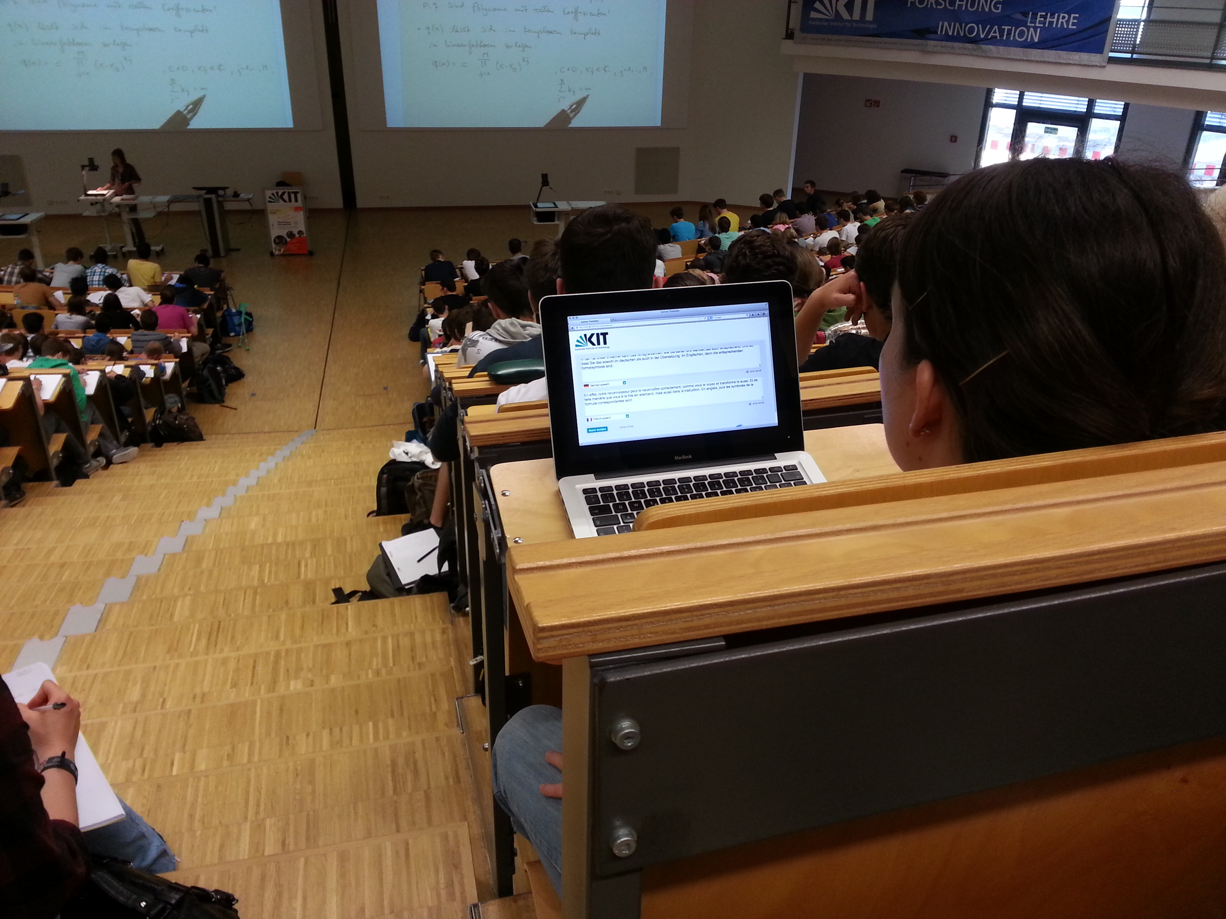

For further information,
please contact:

Nils Ehrenberg

Public Relations and
Marketing

Phone: +49 721 608-48122

Fax: +49 721 608-45681

E-mail:nils.ehrenberg@kit.edu

Johanna Häs

FZI Corporate Communications and Media

Phone: +49 721 9654-904

Fax: +49 721 9654-905

E-mail: haes@fzi.de

Subtitles on the laptop: Foreign students can follow German lectures more easily with the simultaneous translation system. (Photo: KIT/ M. Breig)

More stable power grids and quicker accident care: When used properly, digital data may be of high benefit. However, electronic processing also facilitates data abuse. For this reason, Karlsruhe Institute of Technology (KIT) and the FZI Research Center for Information Technology develop holistic approaches to enhancing intrinsic security. Latest concepts will be presented at the CeBIT next week (hall 9, booth D13).

NurseEye: Digital Fall Detection in Compliance with Data Protection Legislation

It happens quickly: A patient at the hospital or nursing home falls on the corridor, no help is in sight. In such cases, the “NurseEye” video monitoring system might help. The system makes recordings of outdoor areas, corridors, or staircases and evaluates the images. If a fall is detected, NurseEye automatically issues an alarm to the nearest medical staff member, who then looks at the situation on the smartphone, communicates with the patient via the video system, and takes the correct measures. During normal operation, data protection is ensured: Only those images are stored, on which the software detects a fall. All other video data are deleted immediately. NurseEye was developed by KIT in cooperation with the Fraunhofer Institute of Optronics, System Technologies, and Image Exploitation within the Competence Center for Applied Security Technology (KASTEL). The prototype will be presented at CeBIT.

https://www.kastel.kit.edu/63.php

https://www.youtube.com/watch?v=rmpRsnWaRz4

http://www.pkm.kit.edu/neues_aus_dem_KIT_6170.php

http://www.iosb.fraunhofer.de/servlet/is/44685/?highlight=nurseeye

Privacy-respecting Smart Meters

Smart meters supply information about electricity consumption in a quick and detailed manner. These data are required to secure electricity supply in decentralized power grids. However, they might also disclose the everyday life of the electricity consumer. By means of special communication protocols designed by KIT, the advantages of smart metering can be used while maintaining privacy. Before they are sent, the measured data are cooperatively concealed in a self-organized manner using randomly generated masking data, and they are summarized over several households. The grid operator can no longer draw any conclusions with respect to the original household data. But the total consumption of the group of consumers needed for grid control can be derived. The new communication concept can be implemented in a simple peer-to-peer mechanism with a small computation and cost expenditure only. No additional infrastructure is needed. At the CeBIT, privacy-respecting smart metering will be illustrated by a large-format demonstrator.

http://www.kit.edu/kit/english/pi_2014_15838.php

https://www.kastel.kit.edu/61.php

Automatic Simultaneous Translation

Language barriers often prevent free exchange of information. Spoken contents in particular, such as lectures, speeches, or internet videos, require a minimum knowledge of the respective foreign language. At KIT, the first automatic computer-based simultaneous translation service worldwide has been applied in selected lectures for two years now. The lecture translator automatically records the words spoken by the lecturer, transcribes the text into a written version, and translates it into English in real time. Students can follow the lecture via their PC or mobile phone. Due to its grammar, German has been considered a big challenge for a long time. The prototype system developed by KIT masters this challenge reliably now and can be operated regularly during the lecture. At the KIT booth (hall 9, booth D13), the lecture translator will be presented live during the whole CeBIT week. In addition, other new technologies for oral and text translations will be presented by the KIT-coordinated EU project EU-BRIDGE on March 17, 2015, at the Convention Center (rooms 108 – 110). (Demo sessions at 11, 13, and 15 hrs).

http://www.kit.edu/kit/english/pi_2012_10978.php

http://www.eu-bridge.eu/102.php

KASTEL: Research and Higher Education Relating to IT Security

The Competence Center for Applied Security Technology (KASTEL) at KIT pools activities in the areas of computer science, economics, and law for the joint development of secure IT applications. KASTEL cooperates with industry for the joint development of IT products with reliable and reproducible security guarantees. An example is the software security method Blurry Box. It was recently granted the German IT Security Prize. KASTEL and the KIT Department of Informatics offer students the opportunity to pass a comprehensive studies program and to specialize in IT security. This qualification is comparable to a specialized master’s degree and opens up interesting perspectives on the labor market. At the CeBIT, contact partners will be available to answer questions of industry partners and students.

KASTEL: https://www.kastel.kit.edu/index.php

KASTEL certificate: https://www.kastel.kit.edu/64.php

Blurry Box: http://www.kit.edu/kit/english/pi_2014_15864.php

easierLife: Safe at Home without Emergency Button

An assistance system that is not only easy to install and to operate, but also brings certainty that older relatives and friends are doing well. With this objective, four young scientists developed the easierLife system. The sensors replacing the conventional emergency button have already been tested successfully at about 100 households by the FZI Research Center for Information Technology and its partners in the healthcare sector. With easierLife, the four researchers involved started their own business.

The wireless sensors of the easierLife system detect movements and habits at home. If something is wrong, they automatically issue a message or an emergency call. With this information, relatives and nursing staff can prevent critical situations. The persons receiving the information and the type of information authorized persons are to see can be adjusted in detail. The data are protected against unauthorized read-out by encoding using the SSL standard applied in online banking and access protection.

http://url.fzi.de/easierlife

http://www.easierlife.de

https://www.youtube.com/watch?v=8geIahxXo6Y

Software Security for Industry Automation: Measures against Counterfeiting of Merchandise and Sabotage

Industry 4.0 among others means the combination of robotics and software control of production systems. For this, additional security measures are required. Enhanced use of IT and the higher degree of networking make systems more susceptible to manipulation. In addition, the intellectual property contained in the systems has to be protected.

The CeBIT demonstrator will illustrate security of a robot control system. A manipulation-proof USB dongle supplies the cryptographic mechanisms needed for the security method. The protected control only works together with the dongle. If the dongle is lacking, the software is useless and the complete system as well as all components involved in the process are deactivated. Attackers cannot copy the software or analyze its internal functioning. Manipulations and sabotage are made more difficult.

http://url.fzi.de/softwareschutz

http://www.fzi.de/sicherheit

Model-based Security Engineering

Safety-critical systems and infrastructures are increasingly operated in open, worldwide networks and in connection with the internet. However, methodological security development support has not yet been established for the early concept phases in particular. At the CeBIT, a scientific prototype for support relating to structured security development will be presented. By means of the model-based approach, various requirements and framework conditions, standards, system architectures, and attack scenarios can be considered. This makes the development process transparent and reproducible. Solution alternatives can be analyzed and evaluated from various perspectives. Graphics and the required documentations are supported directly by the model. The model-based approach is aimed at enhancing efficiency and quality, managing complexity, identifying weaknesses and difficulties at an early stage, and ensuring a high level of security.

Information on the presence of KIT at CeBIT can also be found at www.pkm.kit.edu/cebit2015.php.
Karlsruhe Institute of Technology (KIT) is a public corporation pursuing the tasks of a state university of Baden-Württemberg and of a national research center of the Helmholtz Association. The KIT mission combines the three strategic lines of activity of research, higher education, and innovation. With about 9,400 employees and 24,500 students, KIT is one of the big institutions of research and higher education in natural sciences and engineering in Europe.

The FZI Research Center for Information Technology at the Karlsruhe Institute of Technology is a non-profit institution for applied research into information technology and technology transfer. Its task is to provide businesses and public institutions with the latest research findings in information technology. It also qualifies young scientists for their career in academics or business as well as self-employment. Led by professors from various departments, research teams at FZI interdisciplinarily develop and prototype concepts, software, hardware, and systems solutions for their clients.
This press release is available on the internet at www.kit.edu.

The photo of printing quality may be downloaded under www.kit.edu or requested by mail to presse@kit.edu or phone +49 721 608-4 7414. The photo may be used in the context given above exclusively.

